Guitar Song Book Project
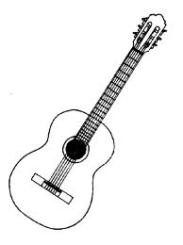

- Compile a collection of 15 songs to play on guitar. All songs must have lyrics and chord charts or tab. If there is a solo, please find it in tab and put it with your lyrics.
(4 pts per song)

2. You may only use five songs previously worked on as a class. You may also include the song that you chose for your previous poster project.

3. You will be responsible for learning how to play all fifteen songs. If there is a complicated solo in tab, you may omit that part. You must demonstrate both knowledge of the chords and strum patterns.
(25 pts)

4. Include a Master Chord Chart page that includes all of the chords used in all of your songs. It may include additional chords as well.
(5 pts)

5. Make a title page for your Song Book and bind it. Preferably a three ring binder or other form of booklet.
(5 pts)

6. Include a Table of Contents (The order of songs and what page they are on.)
(5 Pts)

Due Date:
Song Book is due Friday, December 5th. I will listen to your songs on the 8th-12^{t}

Grading Rubric
Guitar Song Book
(Final Project)

Name: |  |  | Final Grade:
Element | Possible Points | Points Earned
Title Page (Creativity) | 5 pts
Table of Contents | 5 pts
Chord Bank | 5 pts
15 Songs  - Title on each page  - Lyrics/Form  - Chords written above lyrics | 4 pts ea.  (60 pts)
Performance of Three Songs | 25 pts
FINAL PROJECT GRADE

